Matter Quick Audit

Overall simple app so not much to fuck up, but good job JAJA 🫶

**Api 1**

naming inconsistency scripts 1

why is there an emails folder 1

dead code 1

**Admin 1**

sidebar not le stud style 2

async function inside of useEffect 2

**App 2**

Same feedback as admin 2

# Api

## naming inconsistency scripts

Why are scripts not inside src

Better naming, storing for the scripts since they seem to be important and useful

## why is there an emails folder

Emails folder ? Why are we not using brevo templates ?

## dead code

Some code commented out, remove?   
<https://github.com/selego/matteriality/blob/main/api/src/controllers/campaign_indicator.js>

# Admin

Components clean

## sidebar not le stud style

* Use the other layout /drawer instead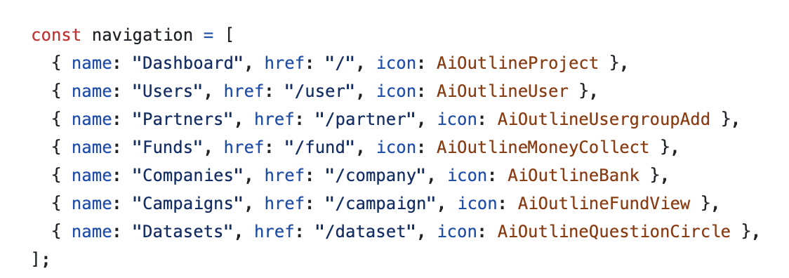

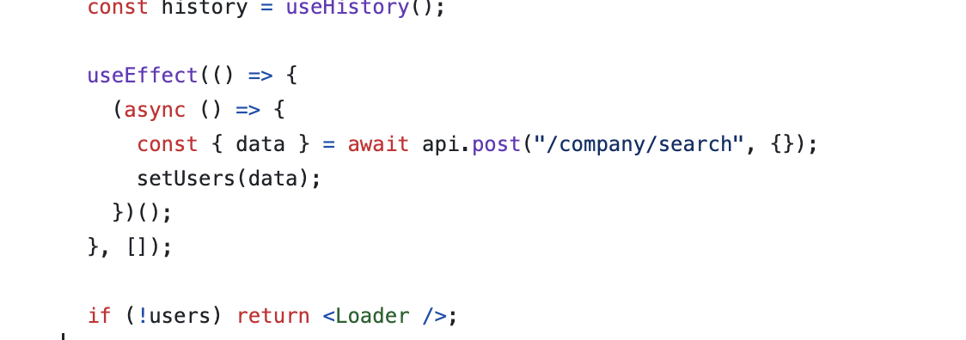

## async function inside of useEffect

Get those asyncs out

# App

## Same feedback as admin

# 